Partnership Section 117 Aftercare Workforce Competency Framework

1. Purpose of the Competency Framework

This framework sets out the core competencies required across the multi-agency workforce responsible for the planning, delivery, review and governance of Section 117 Mental Health Act aftercare.

Its purpose is to:
- strengthen legal literacy and consistency
- support lawful, person-centred and strengths-based practice
- reduce system risk arising from variable understanding of Section 117
- support joint accountability between Integrated Care Boards (ICBs), Local Authorities and NHS Trusts; and
- provide a shared benchmark for training, supervision, audit and assurance.

This framework should be used alongside:
- the Joint Section 117 Policy
- assessment and review templates
- the Section 117 Partnership Register; and
- the annual audit framework.

2. Scope

This framework applies to all staff who influence or make decisions about Section 117 aftercare, including:
- social workers and occupational therapists
- care coordinators
- inpatient and community mental health clinicians
- housing and accommodation leads
- commissioners and panel members
- managers and senior leaders
- quality assurance, audit and governance staff

3. Competency Structure

Competencies are grouped into six domains, reflecting the end-to-end Section 117 pathway and the nine Pillars of “What Good Looks Like”.

Each domain sets out:
- Core competency statements
- Expected behaviours
- Application at three levels:
  - Practitioner
  - Senior/Specialist Practitioner
  - Leader/System Role
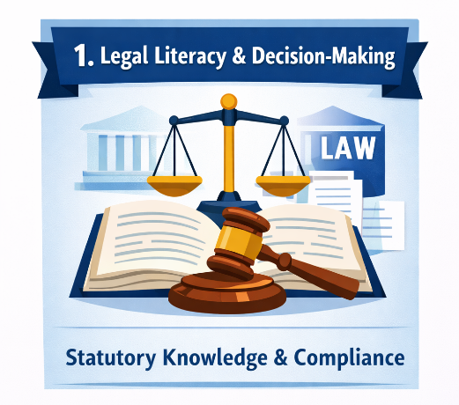
Domain 1: Legal Literacy and Statutory Decision-Making
(Pillars 1, 7 and 9)

Core Competency
Staff understand and correctly apply the legal basis, statutory tests and case law governing Section 117 aftercare.

Expected Behaviours
- Accurately identify Section 117 entitlement based on detention status
- Apply the two statutory tests consistently
- Distinguish lawfully between Section 117, Continuing Healthcare (CHC) and Care Act duties
- Avoid unlawful charging, time-limiting or unilateral decision-making
- Record decisions with a clear legal rationale

Practitioner Level
- Can explain Section 117 entitlement to individuals and carers
- Can identify which needs fall within Section 117
- Can record lawful decisions clearly in assessments and reviews

Senior/Specialist Level
- Provides advice and challenge on complex or disputed cases
- Identifies and addresses unlawful or inconsistent practice
- Supports others to improve legal literacy

Leader/System Level
- Ensures governance, policies and panels reflect statute and case law
- Oversees dispute resolution and risk escalation
- Uses audit findings to address systemic legal risk

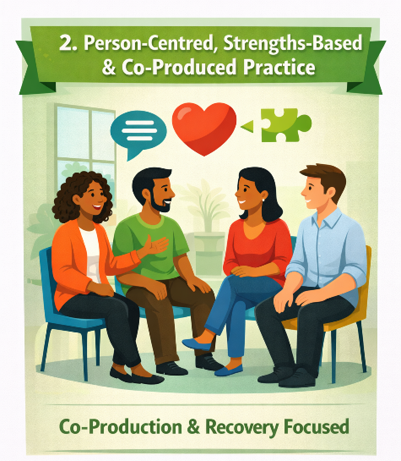
Domain 2: Person-Centred, Strengths-Based and Co-Produced Practice

(Pillars 2, 4, 5 and 6)

Core Competency
Staff work in partnership with individuals, carers and advocates to co-produce aftercare that promotes recovery, autonomy and wellbeing.

Expected Behaviours
- Start from the person’s strengths, aspirations and goals
- Evidence meaningful involvement and shared decision-making
- Respect cultural identity, communication needs and preferences
- Use recovery-focused language and approaches
- Actively involve carers (with consent)
Practitioner Level
- Co-produces assessments and plans
- Records the person’s voice clearly
- Uses strengths-based tools (e.g. WRAP)

Senior/Specialist Level
- Coaches others in co-production and trauma-informed practice
- Addresses exclusionary or medicalised practice
- Ensures advocacy is used appropriately

Leader/System Level
- Embeds co-production into policy, training and QA
- Uses lived experience feedback to shape systems
- Champions inclusive practice across partners

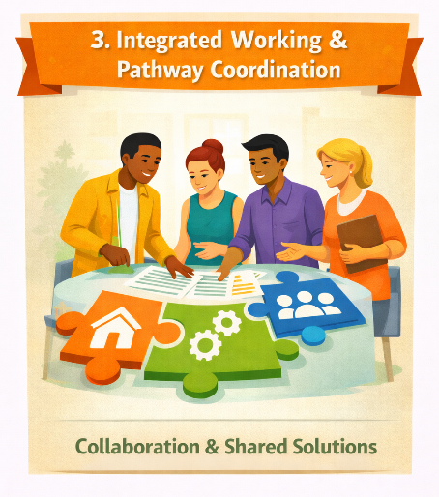
Domain 3: Integrated Working and Pathway Coordination

(Pillars 3 and 8)

Core Competency
Staff work collaboratively across organisational boundaries to deliver seamless, integrated aftercare.

Expected Behaviours
- Share information lawfully and proportionately
- Work across health, social care, housing and VCSE partners
- Prevent fragmentation at admission, discharge and transition points
- Maintain continuity of relationships where possible

Practitioner Level
- Participates in MDT working
- Coordinates effectively with partner agencies
- Ensures timely referrals and handovers

Senior/Specialist Level
- Resolves interface issues between services
- Supports pathway redesign and problem-solving
- Improves cross-agency communication

Leader/System Level
- Oversees integrated pathways and governance
- Ensures information-sharing agreements are in place
- Removes structural barriers to joint working

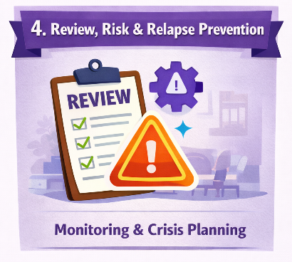
Domain 4: Review, Risk and Relapse Prevention
(Pillars 4, 5 and 9)

Core Competency
Staff proactively review Section 117 aftercare to prevent deterioration, manage risk and reduce readmission.

Expected Behaviours
- Complete timely initial and annual reviews
- Identify early warning signs and relapse indicators
- Use positive risk enablement approaches
- Ensure contingency and crisis plans are in place

Practitioner Level
- Undertakes outcome-focused reviews
- Updates plans in response to change
- Works proactively rather than reactively

Senior/Specialist Level
- Quality-assures reviews and endings
- Supports complex risk formulation
- Challenges unsafe or premature endings

Leader/System Level
- Monitors review compliance through the register
- Oversees escalation where risk is increasing
- Ensures learning from crises and readmissions
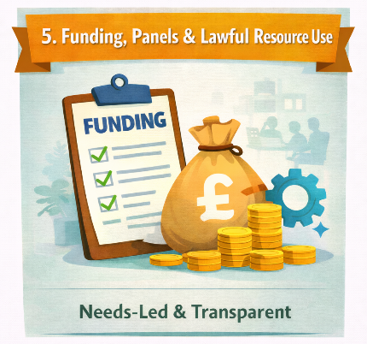
Domain 5: Funding, Panels and Lawful Resource Use
(Pillar 7)

Core Competency
Staff make and support funding decisions that are needs-led, lawful and transparent.

Expected Behaviours
- Separate funding decisions from service labels
- Apply the “accommodation-plus” principle correctly
- Avoid cost-driven or arbitrary decisions
- Escalate disputes promptly and lawfully

Practitioner Level
- Understands what can and cannot be funded under Section 117
- Provides clear evidence to support funding decisions

Senior/Specialist Level
- Chairs or advises panels
- Resolves funding disputes using legal principles
- Supports consistent decision-making

Leader/System Level
- Ensures panels operate lawfully
- Oversees pooled or joint funding arrangements
- Addresses patterns of dispute or delay

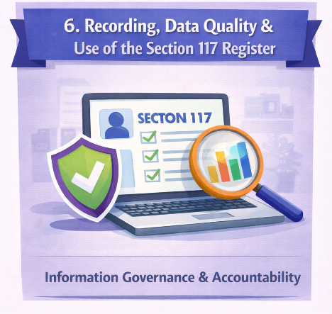
Domain 6: Recording, Data Quality and Use of the Section 117 Register
(Pillars 8 and 9)

Core Competency
Staff maintain high-quality records and use the Section 117 Partnership Register as an active assurance tool.

Expected Behaviours
- Record entitlement, plans, reviews and decisions accurately
- Keep register entries up to date
- Use data to identify risk, gaps and improvement needs
- Support audit and CQC readiness

Practitioner Level
- Updates records promptly and accurately
- Understands why the register matters

Senior/Specialist Level
- Monitors data quality and compliance
- Uses register data to prioritise action
- Supports audit activity

Leader/System Level
- Uses register data for governance and assurance
- Oversees regular register review
- Ensures improvement actions are implemented

4. Using the Framework

Local systems should use this framework to:
- design mandatory training programmes
- inform supervision and appraisal
- support recruitment and role profiles
- underpin audit and quality assurance

Competency gaps identified through audit or supervision should trigger:
- targeted training
- reflective supervision; and
- system-level improvement actions where required.

5. Review and Ownership

This framework should be:
- jointly owned by the ICB and Local Authority
- reviewed annually; and
- updated in line with legislative or Code of Practice changes.

